✔️[C++] Shortest Recursive Solution | Detailed Explanation with images

[_LeetCoder25_](https://leetcode.com/_LeetCoder25_/)



2752

27069

Nov 22, 2021

C++

C

Recursion

**Firstly, thanks for refering to my solution in advance :)**  
**Please UPVOTE🔼 if you like it :)**

When we delete a node from a Binary Search Tree(BST), the BST properties should remain the same.  
Hence, we have 3 cases for deleting a node from a BST :

1. ***The node is a leaf node*** - In this cases, we can just delete the node and return the root, since deleting any elaf node doesn't affect the remainig tree.  
   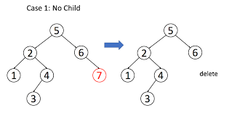
2. ***The node has one child*** - In this case, replace the node with the child node and return the root.  
   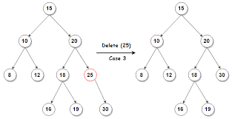
3. ***The node has 2 children*** - In this case, in order to conserve the BST properties, we need to replace the node with it's inorder successor (The next node that comes in the inorder traversal) i.e; we need to replace it with either :  
   1. The greatest value node in it's left subtree (or)  
   2. The smallest value node in it's right subtree  
   and return the root.  
   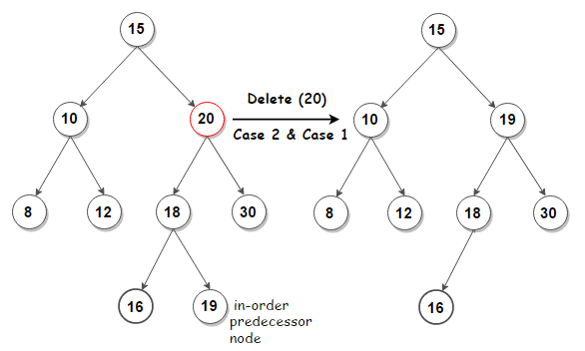

**Time Complexity :** O(h) - h = height of the tree.  
(Worst case Time Complexity : O(n) )

**Code :**

class Solution {

public:

TreeNode* deleteNode(TreeNode* root, int key) {

if(root)

if(key < root->val) root->left = deleteNode(root->left, key); //We frecursively call the function until we find the target node

else if(key > root->val) root->right = deleteNode(root->right, key);

else{

if(!root->left && !root->right) return NULL; //No child condition

if (!root->left || !root->right)

return root->left ? root->left : root->right; //One child contion -> replace the node with it's child

//Two child condition

TreeNode* temp = root->left; //(or) TreeNode *temp = root->right;

while(temp->right != NULL) temp = temp->right; // while(temp->left != NULL) temp = temp->left;

root->val = temp->val; // root->val = temp->val;

root->left = deleteNode(root->left, temp->val); // root->right = deleteNode(root->right, temp);

}

return root;

}

};